Bird Olympics Datasheet
How do you compare to a bird?

- Flapping challenge: Some birds flap their arms really fast to be able to fly. The master flapper award goes to the rufous hummingbird which can flap its wings 1400 times in 20 seconds! That’s equivalent to 70 flaps per second! How do you compare?

Bird | # flaps/ 20 sec | # flaps/ min (# x 3)
Crow | 40
Pigeon | 60
Peregrine Falcon | 86
Carolina Chickadee | 540
Rufous Hummingbird | 1400
You

- Staring contest: Owls can stare at objects for hours without blinking. Let’s see how you compare to an owl. Find a partner. Face them and then close your eyes. When we say ‘go’, hold up your hand and see how long you can stare at each other without blinking. When you blink, put down your hand.

  - Length of time you can stare without blinking: _______________________________

- Hold-your-breath challenge: Cormorants have to dive deep underwater to catch their prey. They can hold their breath up to 15 minutes or 900 seconds! How long can you hold your breath?

  - Length of time you hold your breath: _______________________________________

- Station 1: Wingspan. Birds come in all different shapes and sizes. Some birds are really large and have long wingspans while others are smaller. Measure your wingspan and see what bird has a similar length. Check out the graphic below to see the similar bones in human arms and bird wings. How are an arm and wing similar? How are they different?
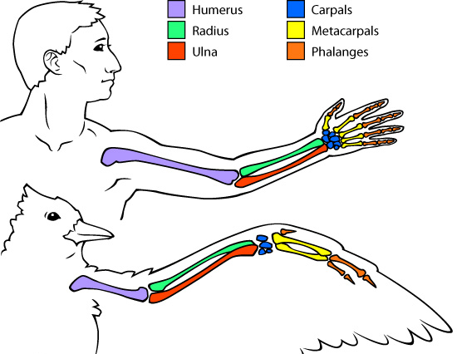
  - Your wingspan:_____________

  - Similar bird: _______________

- Station 2: Birds and Bernoulli. What do birds, airplanes, and sticking shower curtains have in common? If you said, “movement and Bernoulli’s principle”, you would be correct. Bernoulli’s principle says when air speeds up, its pressure drops. Based on this principle, both bird wings and airplanes are curved to allow for air flow above the wing to move faster and slower moving air below the wing to push harder and force the wing to move upward. Using the various materials, construct your best bird and see how far it can fly!

  - How far can your bird fly? _____________________

- Station 3: The Nose Knows. Did you know? A turkey vulture can sense smells up to 200 yards away! Their nose can distinguish the smells of living animals versus dead animals. Their sense of smell is so acute that engineers have used vultures to find leaks in a pipeline that was 42 miles long! Can you distinguish the smells of the 3 jars? (Don’t worry- nothing’s dead here!).

  - Scent 1: _____________________________
  - Scent 2: _____________________________
  - Scent 3: _____________________________

- Station 4: Track, Field, and Air: the 20 Yard Dash! Time to work on some cardio and math skills! The fastest bird in the world, the peregrine falcon, can dive at speeds of up to 175-200 miles per hour! In comparison, species like house sparrows can fly up to 20 mph, crows fly 3-45 mph, and mallards fly 45-60 mph. Check out how fast you can run 20 yards and then calculate how fast that would be in miles per hour!

  - Your time (seconds): _____________________

Fill it Out:
Equation:
20 1 3600
________ X ________ X ________
________ 1760 1

20 yards 1 mile 3600 seconds
________ X ________ X ________
Your time 1760 yards 1 hour

- My Speed ________________ mph

